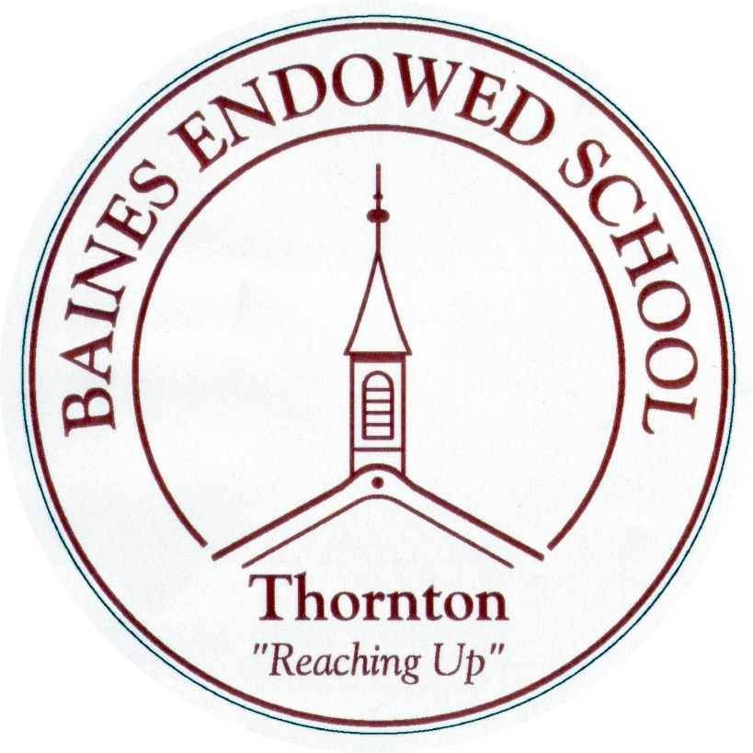

Whole-school Food and Drink Policy
September 2022
Baines Endowed VC Primary School

WHOLE SCHOOL FOOD POLICY

In preparing this policy we have taken into account the Public Health Report, published in 2014, by Public Health England and the NAHT.

Principles

At Baines Endowed VC Primary School we believe that all aspects of food and nutrition in school promote health and wellbeing of staff, pupils, and visitors to the school.
The pupils will have a voice over aspects of nutrition through the curriculum, class discussion and the School Council, where applicable. We agree with the research that shows links between pupil health and wellbeing and attainment and this is part of our guiding principles.

Aims

• To ensure that all aspects of food and drink in school promote the health and well being of pupils, staff and visitors
• To satisfy the Government’s standards for food and nutrition

Application

This policy covers the areas of:
➢ Break-time snacks, including those brought from home
➢ Milk
➢ Water
➢ School lunches, including packed lunches
➢ Curriculum
➢ After school clubs and events
Our procedures apply to all staff, pupils, parents, governors and partner agencies working within the school.

Break-time Snacks

Fruit and vegetables provided through the Government Scheme will be available for all pupils in KS1.
Any snacks brought from home will be restricted to fruit or vegetables unless recommended by a doctor on medical grounds, (e.g. dietary need, diabetes etc.) KS2 have access to snacks made freshly in the school canteen. They are also able to buy juice and milk.

Water

Clean drinking water will be available for all pupils throughout the day and pupils will be encouraged to drink water at frequent intervals. Pupils are only able to use the school water bottle (which has been given to everyone) that they can refill as necessary. Bottles go home at the end of every day to be washed and returned.

School Lunches Including Packed Lunches

At Baines Endowed, all school meals will be prepared following the Government Nutritional Guidelines, as stated in the Public Health Report, published in 2014, by Public Health England and the NAHT “A whole school approach to healthy school meals, universally implemented for all pupils, has shown improvements in academic attainment at key stages 1 and 2, especially for pupils with lower prior
attainment”
We will provide Free School Meals for all KS1 children at our school and encourage parents to take up this offer. This will be done in partnership with the local authority catering service, who commit to providing food which is complaint with all national guidelines. Staff will work with children to provide a clean, safe, attractive and appropriate dining area. We believe that lunchtimes should foster the caring, friendly ethos that governs everything that we do. Children are encouraged to be independent in cutting food and tidying their plates and cutlery away.
If children have a packed lunch we work with parents to support them in choosing healthy options when making packed lunches.

Milk

Our school provides a milk scheme for all pupils, in accordance with Government guidelines. Parents are invited to register their child, via Cool Milk, for participation in this scheme, which provides (189ml) of semi-skimmed milk every day. The milk is free for all children aged under five, or those in receipt of Pupil Premium, and is subsidized for children aged five or older. This is available for KS1 children.

Curriculum

Healthy Eating will be addressed in areas of the curriculum, e.g. PSHE, DT, Science.
Through various topics, pupils will have the opportunity to cook and eat different foods and staff aim to promote healthy choices and multi-cultural options where possible.

After School Clubs and Events

The food and drink provided at after school clubs and events will be in line with the Whole School Food Policy. Some exceptions will take place, e.g. school fayres, discos, where the well-being and fun element of the occasion will override the healthy option.
Similarly, occasionally the adults in school will have occasion for celebration and these may involve the consuming of unhealthy options, e.g. cakes! These will only be eaten in moderation.

Staff Support and Training

All staff and governors will be informed and kept up to date with any changes in policy, any new information, initiatives or procedures involved in food hygiene, health and safety and nutrition as the need arises throughout the year.

Assessment, Monitoring, Evaluation and Review

Assessment of the curriculum will take place by class teachers and coordinators. Monitoring, evaluation and review of this policy and its contents, and its workability will be the responsibility of the Head teacher, Senior Leadership Team and the PSHE co-ordinator.

E.Hedges - Reviewed April 2020
L. Hedges – Reviewed July 2021
G. Finney – Reviewed September 2022

