Baines Endowed VC School

RE Policy

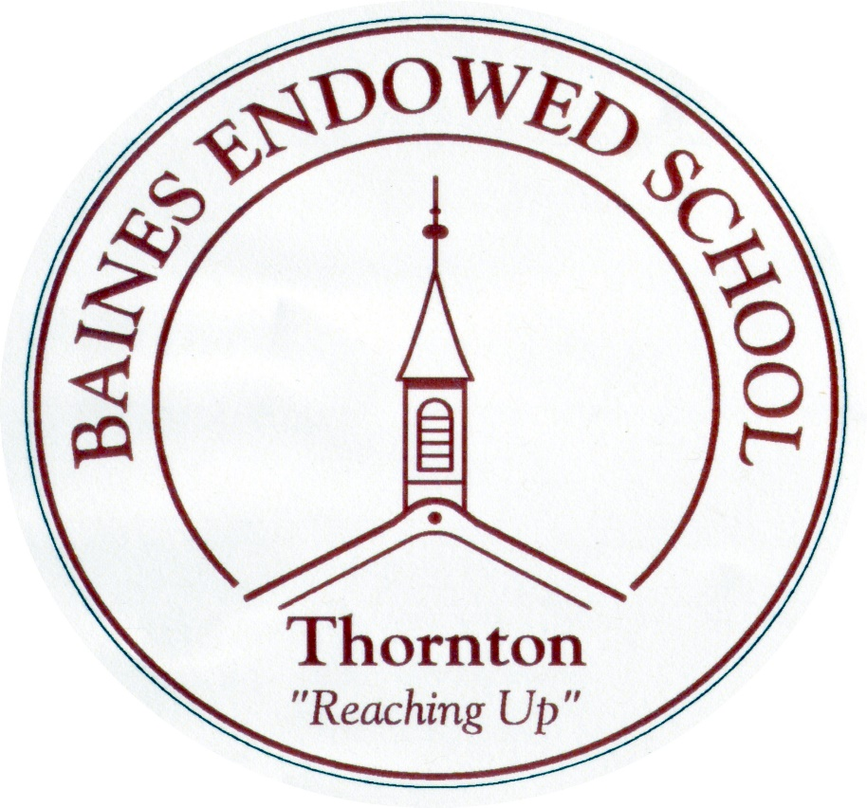

September 2022

Religious Education Policy

The role of Religious Education is to provide opportunities for pupils to study and reflect on the beliefs and practices on which people base their lives so that respect for those with religious and other beliefs is well founded. It promotes attitudes and values necessary for responsible citizenship in a democratic and pluralistic society. It is essential to promote understanding between religious groups in our increasingly diverse society.

The school’s vision and educational aims for Religious Education are to provide a rigorous academic curriculum that is ambitious, challenging, enriching and inclusive. This is in line with the school’s aim to encourage high aspirations in order to maximise progress and enable all pupils to experience the joy of success. Our aims for RE also reflect the intent of the locally agreed syllabus which is 'to support pupils' personal search for meaning by engaging enquiry into the question 'what does it mean to be human?' through exploring answers offered by religion and belief.
Our intent is to provide an academic RE curriculum that enables pupils to hold balanced and informed conversations about religion and worldviews – children will become religiously literate.

Aims for RE
Our aims are drawn from the Lancashire Agreed Syllabus and should enable pupils to:
- To develop knowledge and understanding of Christianity and the other main world religions represented in Britain at this time. Children should develop an understanding of the influence of beliefs, values and traditions on individuals, communities, societies and cultures.
- Apply academic skills such as analysis and critical thinking, to their approach to the study of religion.
- Learn more about themselves and their place in the world through an academic exploration of religions and world views.
- Enhance their spiritual, moral, cultural and social development by:
- Developing an awareness of the fundamental questions of life raised by human experience and how religious teaching can relate to these fundamental questions.
- By responding to such questions with reference to the teachings and practices of religions and to their understanding and experience.
- By reflecting of their own beliefs, values and experiences in light of their study.
- To develop a positive attitude towards living in a society where there is a diversity of religious beliefs and culture. To examine what is true for our own beliefs and values while learning to respect what is true for others.

Planning and Delivery
The RE curriculum is planned to develop knowledge and understanding of religious beliefs, teachings and practices. Pupils have opportunities to develop their religious literacy and to master the skills needed to analyse and interpret expressions of faith. The core beliefs and teachings of the religions studied spiral through the curriculum so that pupils develop a depth of understanding over time. The planning and delivery of RE aims for children to understand the narrative of the religion as opposed to a collection of sayings and generalisations.

We have a clear plan for what pupils should know and be able to do in RE by the end of each key stage. This is explicit in planning and there is a shared understanding across all those who teach RE.

Legal regulations regarding the teaching of RE are adhered to:
- Whilst RE is not part of the National Curriculum it is taught as a legal requirement.
- The teaching of RE is allocated 5% of the timetabled teaching time.
- Parents retain the right to withdraw their children from RE if they wish to do so.
- RE does not seek to urge religious beliefs on pupils by promoting one religion over another. RE is not the same as collective worship which has its own place within school life.

Development of Skills and Attitudes

Skills
In our RE teaching we aim to develop enjoyment of and commitment to learning. We want the best possible progress and highest attainment for all. Pupils are expected to be able to talk and write knowledgeably about religions and belief, using subject specific language accurately and confidently. They should be able to utilise RE specific skills such as making links between beliefs, teachings and practices; analysing and interpreting religious texts and understanding symbolism in images, actions and metaphorical language.
Curriculum overviews have been created, in which each topic in each year group is set out so that teachers can see the skills children will have developed in previous years and what skills they are expected to learn during their new topic. This ensures that learning in progressive in RE and children are constantly developing their religious literacy.

Attitudes
We aim to help pupils to distinguish between right and wrong. We explore and encourage values of commitment, fairness, respect, self-understanding and enquiry. Whilst developing their knowledge we also aim to increase their understanding and appreciation of the diversity of beliefs and cultures that influence individuals and societies. We promote equality of opportunity and challenge discrimination and stereotyping. We aim to develop pupils’ ability to relate to others and work for the common good, becoming a responsible member of society.

Areas of Study
Christianity is studied throughout school, in every year group. Children will have the opportunity to study all of the 6 major world religions within their Primary Education. For most year groups, they will study Christianity principally and a further three religions have been selected to extend RE teaching; Judaism, Islam and Hinduism. Instead of Judaism, Sikhism will be studied in Year 3 and Buddhism will be explored in Year 6. In line with the County Agreed Syllabus the teaching of religions will reflect the fact that the religious traditions in Great Britain are in the main Christian. Teachers have been encouraged to link RE where ever possible to other areas of study in their year group.

Cross Curricular Links
At Baines, we have a creative curriculum, taught through topics which change every half-term. Whilst in the main, RE is taught as a discrete subject, where possible, meaningful links are made. We want to make links where these links enhance RE and contribute to the children’s enjoyment of the subject. We do not, however, want to create tenuous links which would detract from the true nature of RE. Members of staff are encouraged to write complete units of RE work if they feel they would link in a meaningful way with the overall topic for the term.

We aim to link our RE work with other subjects across the curriculum such as Drama, Literacy and Art. This is to prevent pupils seeing RE as a subject in isolation. We aim to embed RE in our curriculum through a range of subjects and approaches. However, as a staff we have agreed to plan RE as a separate subject rather than using our cross curriculum web. Plans will have the question focus sheet attached to ensure the focus for the unit is clear from the beginning. ICT will be used for research, presentation of work and as a teaching resource.

Themed days and visits
On occasions, RE will be taught through a themed day and block of days, where it will enable the children to experience a range of activities related to the religion they are studying. On such occasions, visits or visiting speakers will be arranged wherever possible; to enhance learning experience for the children. The whole school will take part in such activity days and a completely cross curricular approach is taken. Visits to places of interest will be arranged whenever they support and enhance the teaching of RE with school. This contributes to the children’s understanding of the wider world and acceptance of the beliefs of others.

Foundation Stage
RE is a statutory requirement for all pupils in Foundation stage. At Baines we use the exemplary units from the Lancashire Agreed Syllabus 2021 as a starting point for our teaching. In EYFS the children will explore some of the main world festivals such as Christmas, Easter, Diwali, and Ramadhan through continuous provision under the heading Special stories, Special World and Special Times.
RE at Foundation Stage aims to meet the interests and needs of the individual children and is taught through a creative curriculum based approach.

Monitoring RE Provision
We aim to monitor the quality and effectiveness of RE provision within school through a variety of sources.
- Triangulation of RE by looking at the following- book scrutinise, planning reviews and pupil voice interviews.
- Levels of RE attainment will be recorded at the end of every year in line with the new assessment procedures – based on working towards requirements for the year group, working at or exceeding.
- A portfolio of work will be maintained by the subject leader demonstrating the level of achievement across all year groups.
Assessments in RE
Lancashire’s SACRE requires that we report AT1 and AT2 levels at the end of each Key Stage, to enable efficient monitoring of RE provision within school.
To enable accurate assessment to be made the school will use the range of ‘I can…’ statements where expectations of achievements for pupils in each key stage are clearly described. These statements will be displayed in pupils’ books showing clear expectations. Teachers will regularly assess pupils against these requirements and make a judgement regarding progress.

Reports to parents on pupils’ attainment and progress in RE will be made in the annual school report issued at the end of each school year.

Resources
A variety of resources will be used in the teaching of RE where appropriate. These are stored in the Key Stage 2 corridor clearly marked with the relevant religion.
Children have access to school library books, books on loan from Lancashire services, a wide range of ICT materials used in the classroom on interactive whiteboards, artefacts where available and visits / visitors to reinforce classroom teaching.
Different learning styles will be provided for, where appropriate. Whilst RE is a curricular discipline in its own right, there are many cross curricular links which can link RE topics to other subjects on the timetable: Literacy, Drama, Art, Music, DT & PSHE for example. Themed days will be arranged where suitable, to link these subjects and enhance the teaching of RE at Baines.

Vicars regularly visit our school to teach children through assemblies. Other visitors can be arranged to support the teaching of a particular topic.

Inclusion
RE is particularly valuable in areas relating to inclusion, promoting respect for all, appreciating differences in others, and developing a pupil’s self-esteem. When planning activities, teachers should take account of the needs of individual children in their class in order that all children are able to access the RE curriculum. The curriculum should be adapted to meet the needs of individual children or groups whenever necessary and differentiated appropriately. Where parents object to their child learning about a specific religion, the rights of parents to withdraw children from particular RE lessons is upheld by the school.

Radicalisation and Extremism
All staff have received up to date training on child protection issues and are fully aware of the dangers of radicalisation and extremism in the modern world. Any concerns in school would be recorded on a concerns form and the matter would be reported immediately to the Head.

Moral Development
RE has an important role to play in promoting SMSC and the fundamental British Values within the school and this is built into our curriculum plans. RE contributes to pupils’ personal development and well-being and to building integrated communities by promoting mutual respect and tolerance in a diverse society. Studying RE helps develop a knowledge and understanding of the beliefs and values which have shaped and continue to have an important influence on the world that we live in. It provokes challenging questions about the ultimate meaning and purpose of life, beliefs about God, the self and the nature of reality, issues of right and wrong, and what it means to be human.
Our school values include: telling the truth, respecting the rights and property of others, acting considerately towards others, helping those less fortunate and weaker than ourselves, taking personal responsibility for one’s actions, self-discipline. We reject bullying, cheating, deceit, cruelty, irresponsibility and dishonesty.
We hope that before children leave our school they know right from wrong, can articulate their own attitudes and values, can take responsibility for their own actions, recognise the moral dimension in situations, understand the short and long term consequence of their actions for themselves and others, develop a set of socially acceptable values for themselves, and behave consistently in accordance with their principles. This supports our school mission statement:

We are a friendly, safe, caring community in which everyone can be happy and confident and where children can reach their full potential..

Blended learning
By developing a blend of in-school and distance learning, teachers can support students and help to individualise learning, increase learners’ autonomy, motivation and agency and improve learning skills towards becoming self-directed learners.

To do this in Religious Education teachers will set and respond to tasks using online platforms such as Purple Mash, Class Dojo etc. These will be used as homework or work to be completed in school.

Teachers will share videos with parents/carers and children to introduce new units of work. These will highlight learning from previous year groups (where applicable) and the skills that children will have used before and are to build upon. Key vocabulary to be used in the forthcoming unit and skills to be developed will also be introduced.

Review
The specific needs of RE as a subject area will be detailed annually in the school development plan by the subject leader. Previous targets and statement of objectives will be evaluated at this time.

Any staff training required will be delivered by the subject leader and updates from the Lancashire RE support group will be passed on to specific members of staff as required.

This policy will be reviewed annually and updated as required. The original RE policy was written in November 2006 by the RE subject leader.

The policy has since been reviewed annually – September 2010, October 2011, December 2012, November 2013, November 2014, October 2015, September 2016, October 2017, September 2018, October 2019, September 2020, July 2021, September 2022.

This policy has been reviewed and agreed by:

(RE Subject Leader)

(Head teacher)

(Governor)

Date: July 2021

