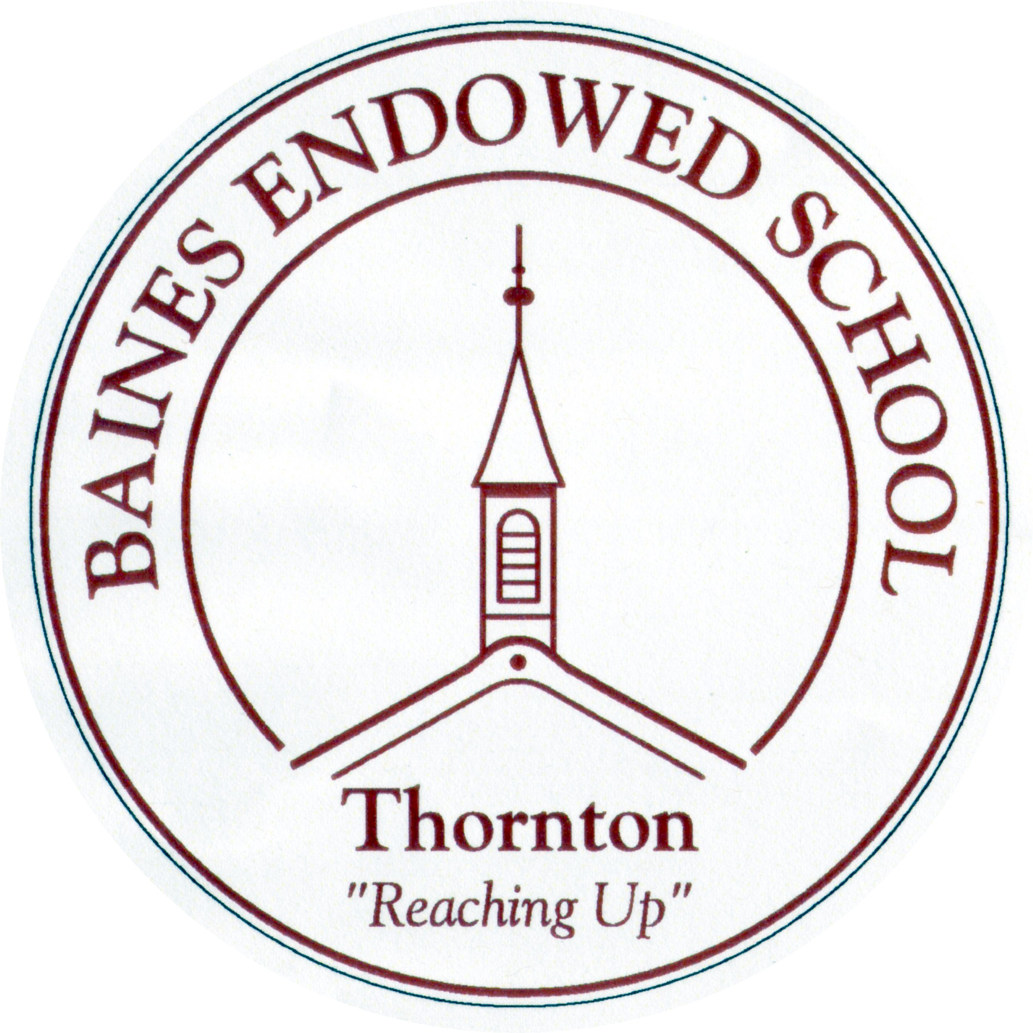

PSHE Policy
September 2022

Baines Endowed VC Primary School

PSHE Policy
Introduction
Personal, Social, Health and Enterprise Education helps to give pupils the knowledge, skills and understanding they need to live confident, healthy, independent lives and to become informed, active, responsible citizens.
It is widely accepted that personal, social and emotional skills are crucial to success and fulfilment in adult life. At Baines Endowed VC Primary School we take the point of view that it is our responsibility to promote the personal, social and emotional development of all our pupils in order to prepare them for their futures. We will achieve this through the teaching of PSHE, supported by cross curricular teaching and learning.

Aims
Through this policy we aim that all children, including children with SEND will:
- have the opportunity to take part in a wide range of activities and experiences across and beyond the curriculum, contributing fully to the life of school and community.
- learn to recognise their own worth, work well with others and become increasingly responsible for their learning.
- reflect on their experiences and develop an understanding of how they are developing personally and socially, tackling many of the spiritual, moral, social and cultural issues that are part of growing up.
- develop the knowledge, skills, understanding, qualities and attitudes they need to foster their own inner lives and well-being.
- gain an understanding of the differences between right and wrong, moral conflict, a concern for others and a desire to do what is right.
- be able to reflect on the consequences of their actions and learn how to forgive themselves and others.
- develop the knowledge, skills, understanding, qualities and attitudes they need in order to make responsible moral decisions and act on them.
- acquire an understanding of the responsibilities and rights of being members of families and communities (local, national and global), and an ability to relate to and work with others.
- display a sense of belonging and an increasing willingness to participate.
- develop the knowledge, skills, understanding, qualities and attitudes they need to make an active contribution to the democratic process in their communities.
- acquire an understanding of cultural traditions and an ability to appreciate and respond to a variety of aesthetic experiences.
- acquire a sense of respect for their own culture and that of others, an interest in others’ way of doing things and curiosity about differences.
Curriculum
PSHE is taking place all the time in school. It is reflected in the ethos of the school, the nature of relationships with, and between staff, the displays in school and the outside environment of the school.

We teach PSHE in a variety of ways. Some of the objectives are covered in dedicated PSHE times. Many of the objectives are covered through other areas of the school’s curriculum e.g. RE, Assemblies, Science and the Creative Curriculum; attitudes and expectations of behaviour promoted by adults in the school.

Forms of curriculum provision may include:

Discrete curriculum time

Teaching PSHE through and in other subjects/curriculum areas where appropriate

Through circle time, school council, eco-committee and other specific meetings

Through class, key stage and whole school assemblies
- Through curriculum enrichment (e.g. focus days/weeks, Sports Day, raising money for school and charities, taking part in local community ventures)

Through visits from supporting agencies/people e.g. School Nurse, Drugs Education Officer, Road safety team, Fire-brigade, Police Liaison Officer, Lifeboat Services etc

Visits from other adults including; parents, members of the community and local religious leaders.
Schemes of work
Throughout Key Stage 1 and 2 the teaching of PSHE follows the Programme of Study set out by The PSHE Association. Circle time and other activities are also recommended to deal with class and pupil issues as and when they arise. As a school close to the sea we also focus on beach and sea safety and tram safety, as well as emphasising and modelling good practise in sun safety.
The PSHE Association Programme of Study is based on three core themes:
- Health and Wellbeing
- Relationships
- Living in the Wider World
All year groups follow the PSHE association core themes and these are split into 6 themes throughout the year: Rights and Responsibilities, Feelings and Friendship, Money, Safety and Risk, Health and Identity.
In Early Years PSHE is taught specifically through the ‘Personal, Social and Emotional Development’ Early Learning Goals as well as through the other areas of learning. (See Early Years Foundation Stage Policy)
Teaching and Learning
Teaching and Learning in PSHE follows the agreed principles set out in the Teaching and Learning Policy. A variety of teaching and learning strategies are used to deliver PSHE which take into account pupils’ age, development, understanding and needs. Pupils will need to work in a safe, secure climate to be able to explore their own and others’ attitudes, values and skills.

Effective PSHE lessons will involve a high level of interaction where each pupil has planned opportunities for learning through:
- The development of a trusting relationship between the teacher and the pupils enabling the consideration of sensitive issues to take place
- Collaborative work
- Circle time activities
- Opportunities for reflection
- Challenge within a safe environment
- Respect for each genuinely made contribution
- Negotiation
- Accommodating new information and skills
- Building on current experience and using first-hand learning to achieve positive ends

Lessons help pupils to realise the nature and consequences of discrimination, teasing, bullying and aggressive behaviours (including cyber bullying), use of prejudice-based language and how to respond and ask for help. It also recognises and explains the consequences of homophobic, biphobic or transphobic bullying or derogatory language.

Most PSHE teaching is carried out by the class teacher. However, certain aspects of the curriculum, such as sex and drugs education may be supported by a specialist teacher such as the School Nurse or a Drugs Education Officer.
A variety of resources are used to support teaching and learning in PSHE. These include the PSHE Association, Lancashire Framework and the SEAL programme. Other materials such as books, puppets and posters are also used to support teaching and learning.

Sensitive and controversial issues are dealt with carefully by all staff, supported by other professionals where appropriate, and always within the parameters of our Safeguarding Policy.

Pupil Voice

At Baines Endowed VC Primary School we believe that the voice of the pupil is essential. The PSHE co-ordinator will interview children on a yearly basis to ascertain their views on the teaching and their learning of PSHE. The School Council will be asked to discuss certain issues relating to PSHE and to take these discussions back to their classes. Key Stage assemblies will be linked to the ‘Value of the Month’ taken from the schools’ value tree display. Children in school will be rewarded if their name is on the value branch at the end of the month.

We believe that it is important that children feel able to ask any questions that they wish and that their questions are valued. However, if necessary, teachers also need to feel able to ask the child to wait for an answer to give them time to consult with the school’s leadership team. (For instance: ‘That is a really interesting question and I need a little time to think because I want to give you a really good answer.’)

Each class also have a question box where pupils who are not comfortable raising questions in an open setting may ask questions to be responded to at a later date.

Parental links

The parent body are informed about PSHE and RSE through the school newsletter and the school website. Parents will be updated on the new RSE scheme of work and will be aware of what their children will be learning throughout the year.
Teachers will communicate with parents prior to any teaching regarding RSE or technical vocabulary – usually by a letter or Class Dojo message.
Parents have the right to withdraw their child from the RSE sessions which take place in Year 6 (Human Reproduction) but this must be put in writing to the Head teacher.

Blended Learning

By developing a blend of in-school and distance learning, teachers can support students and help to individualise learning, increase learners’ autonomy, motivation and agency and improve learning skills towards becoming self-directed learners.
To do this in PSHE, teachers will set and respond to tasks using online platforms such as Purple Mash, Class Dojo etc. These will be used as homework or work to be completed in school.
Teachers will also continue to celebrate positive work and behaviour in weekly praise videos to send to parents and children.

Equalities
PSHE is accessible to all of our children irrespective of their gender, culture, sexual orientation, ability or aptitude. It forms part of the school policy to provide a broad and balanced education to all children. Through our PSHE teaching we provide learning opportunities that enable all pupils to make progress, according to each child’s needs and capabilities. Teaching will take into account the ability, age, readiness, social, religious and cultural backgrounds of our young people and those with English as a second language to ensure that all can fully access PSHE education provision.

We enable pupils to have access to the full range of activities involved in learning PSHE. If activities are outside the classroom, for example, visiting our local church, risk assessments prior to the activity ensure they are safe and appropriate for all pupils.

Assessment, Recording and Reporting
Assessment takes place in accordance with the schools’ Assessment policy. The main process we use to assess pupils progress in PSHE is through observation of how they apply their knowledge, skills and understanding in simulated and real experiences. Some classes will compile their own PSHE scrapbook which will record their discussions and learning on a weekly basis, some children may have a PSHE exercise book and others may evidence discussions with pictures/post-it notes for example.
Celebration of achievement contributes to building pupils’ self-esteem, developing a sense of community and belonging, helps create a positive atmosphere in the school and develops pupil’s sense of pride.
At Baines Endowed VC Primary School we celebrate achievement in a variety of ways including;
- The use of Class Dojo, the Ladder of Success, stickers and team points.
- Thank you post cards sent home to reward good manners or helpful behaviour. These are also displayed in school.
- All children are in a team and points are awarded for good behaviour, tidiness, effort etc. A trophy is given out each week for the winning team and at the end of the year the winning team visits the ice cream van!
- Welfare staff hand out stickers for good behaviour at lunch time and award two certificates in the weekly Achievement Assembly.
- Weekly Merit assemblies take place to celebrate achievements from the week.
- The Baines Endowed Facebook page shares achievements the children have been involved in, both in and out of school.
- Fortnightly newsletters share all of the school achievements with parents.

Links to other policies
Other whole school policies contribute to the personal, social, emotional and enterprise development of pupils. These include:
- Drugs Policy
- Sex and Relationships Policy
- Food Policy
- Behaviour and anti-bullying Policy
- CPD Policy
- All subject Policies
- SEN / MA Policy
- Equalities Policy
- Extended Provision
- Safeguarding Policy
- Confidentiality Policy
- RSE Policy
- SMSC Policy
Leadership, Management, Resourcing and Monitoring
The PSHE Coordinator, alongside the Senior Leadership Team is responsible for:
- Monitoring and evaluating PSHE provision
- Formulating/managing/monitoring/revising assessment procedures for PSHE in line with school policy
- Monitoring and evaluating teaching and learning
The PSHE Coordinator will:
- Attend appropriate courses and update meetings for PSHE then feedback to staff on an informal or formal basis.
- Lead professional development and provide on-going advice/support for colleagues in PSHE.
- Advise staff and the headteacher on developmental issues for PSHE.
- Audit, manage and monitor resources for PSHE.
- Assist with liaison in PSHE with other schools, parents, governors and other outside agencies.
- Liaise with PSHE advisor for school on updates.
E.Hedges – Reviewed September 2019
E.Hedges – Reviewed April 2020
E.Hedges – Reviewed July 2021
E.Hedges - Reviewed July 2022

