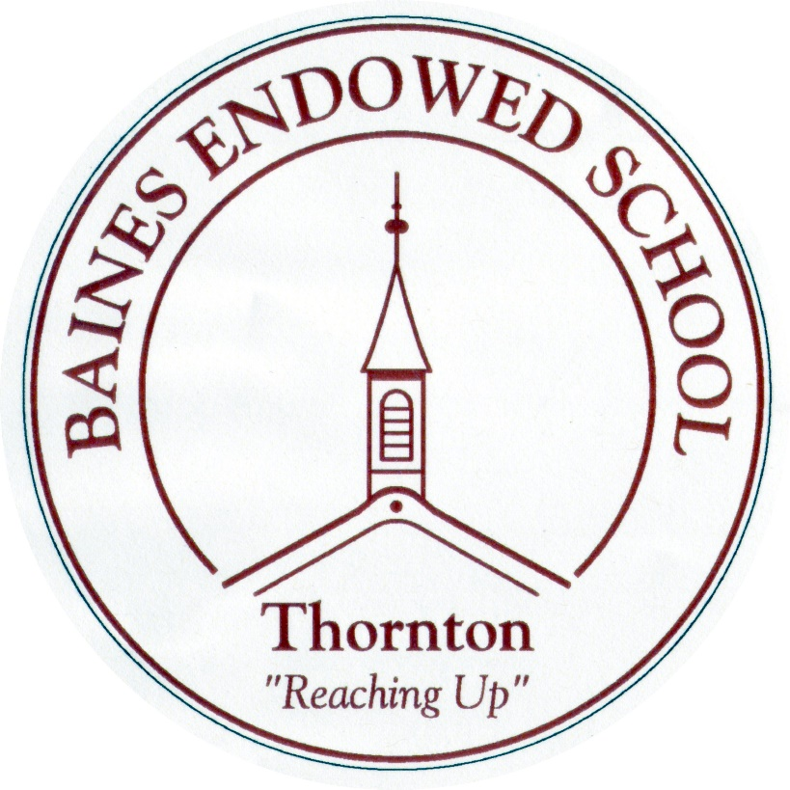

Music Policy
September 2022

POLICY DOCUMENT FOR MUSIC

Last reviewed September 2022

- INTRODUCTION
The purpose of this document is to inform staff and pupils what is expected of them in order to achieve high standards in Music.

Music is a foundation subject within the National Curriculum for Key Stages 1 and 2. The aims of the subject are consistent with the aims of the school and the National Curriculum 2014. The work planned for pupils is skills based and forms part of a Creative Curriculum approach.

Music in the Reception Class is based on the requirements of the Early Years Foundation Stage. It is planned as part of a creative curriculum based on the interests and needs of the individual children.

- PLANNING

The objectives of planning in Music are as follows:
- To set clear achievable aims for the children
- To ensure that the work is matched to the pupils’ capabilities, experience and interests
- To ensure progression, continuity and subject coverage throughout the school
- To develop assessment procedures
- To provide criteria for the monitoring and evaluation of teaching and learning.

Details of the work for a half term are outlined in the teachers’ medium term plans. Short term planning outlines the teachers’ intended work for the week, this may change owing to the teachers’ assessment of pupils’ progress. Future planning will reflect this assessment.

- ROLES AND RESPONSIBILITIES

The Governors of Baines School have overall responsibility for monitoring Music in the school; however, part of this responsibility also belongs to the head teacher, music co-ordinator and other staff.

- TEACHING

Teaching throughout the school is skills based and links to the Lancashire Music Service Interactive Scheme (Charanga) and Whole Class Ensemble Tuition. The teaching provides experiences for the children appropriate to their age group and ability usually in the form of oral, written or practical activities.

- Whole class teaching
- Group and paired work
- Individual work
- A wide range of music including those from different times and cultures
- The use of ICT to record, create and manipulate sound
- A selection of musical activities that integrate performing, composing and listening.

In addition, there are opportunities for the all the children from Reception to Year 5 to take part in the Whole Class Ensemble Tuition Scheme for at least some part of the year. Instruments include djembe drums, brass, woodwind and strings. Peripatetic lessons are available throughout Key Stage 2 on strings, guitar, woodwind, brass and singing. Ensemble lessons are provided by Rock Steady Music School.

- PROMOTING SPIRITUAL, MORAL, SOCIAL AND CULTURAL DEVELOPMENT

Music makes a contribution to pupils’ development in the above areas:

- Through developing pupils’ awareness of the power of music to take the listener out of the commonplace and helping them use music to express and reflect their own thoughts and feelings,
- Through helping pupils exercise responsibility in the choices and decisions they, and others make as part of the creative process, valuing their own and others’ work and recognising the effect of music,
- Through helping pupils share music making and recognise the need for different roles in group performance,
- Through helping pupils recognise how music influences and reflects the way people think and feel, relating music to time and place and through analysing, evaluating and reflecting on music from contrasting traditions.

- PROMOTING SKILLS ACROSS THE NATIONAL CURRICULUM

Music makes a contribution to developing pupils’ skills in many areas, including the following:
- communication
- application of number
- information technology
- working with others
- improving their own learning and performance
- problem solving
- thinking skills

- THE AIMS AND INTENT OF MUSIC

AIMS: To develop children’s knowledge, skills and understanding of music by giving them opportunity to:

- control sounds through singing and playing
- create and develop musical ideas
- respond and review their own work and the work of others
- listen and apply knowledge and understanding
- communicate through presenting music to different audiences and discussing and share ideas
- develop ICT skills to compose, record and perform music
- recognise the need for perseverance and the ability to work independently
- develop thinking skills through analysis and evaluation.

INTENT:
- We intend for all children at Baines to be given a wide range of music experiences and opportunities.
- To build a musical curriculum which develops learning and results in the acquisition of knowledge and improved well-being.
- For children to experience a wide range of musical instruments.
- For children’s musical skills to be built on year after year.
- To promote a love of music and singing across a broadened curriculum so that all children know more, remember more and understand more.

- BLENDED LEARNING
- By developing a blend of in-school and distance learning, teachers can support students and help to individualise learning, increase learners’ autonomy, motivation and agency and improve learning skills towards becoming self-directed learners.
- To do this in Music, teachers will set and respond to tasks using online platforms such as YUMU and Purple Mash.
- Teachers will share videos with parents/carers and children to introduce new units of work. These will highlight learning from previous year groups (where applicable) and the skills that children will have used before and are to build upon. Key vocabulary to be used in the forthcoming unit and skills to be developed will also be introduced.
- ONLINE SAFETY
- Due to the increase in use of internet connected devices and more work being completed online, online safety is an essential part of all curriculum areas.
- In music the children may be expected to complete work online in school or at home.
- Online safety is taught as a discrete part of the computing curriculum and reinforced through regular, safeguarding assemblies. Nevertheless, when the internet is used for music, children are reminded of the golden rules of online safety:
- Don’t share personal information
- Be polite, kind and respectful
- Tell a trusted adult if you come across something that makes you feel uncomfortable or unhappy.

N. Holland
This policy was written in October 2010 and will be reviewed annually.
Last reviewed September 2022.

