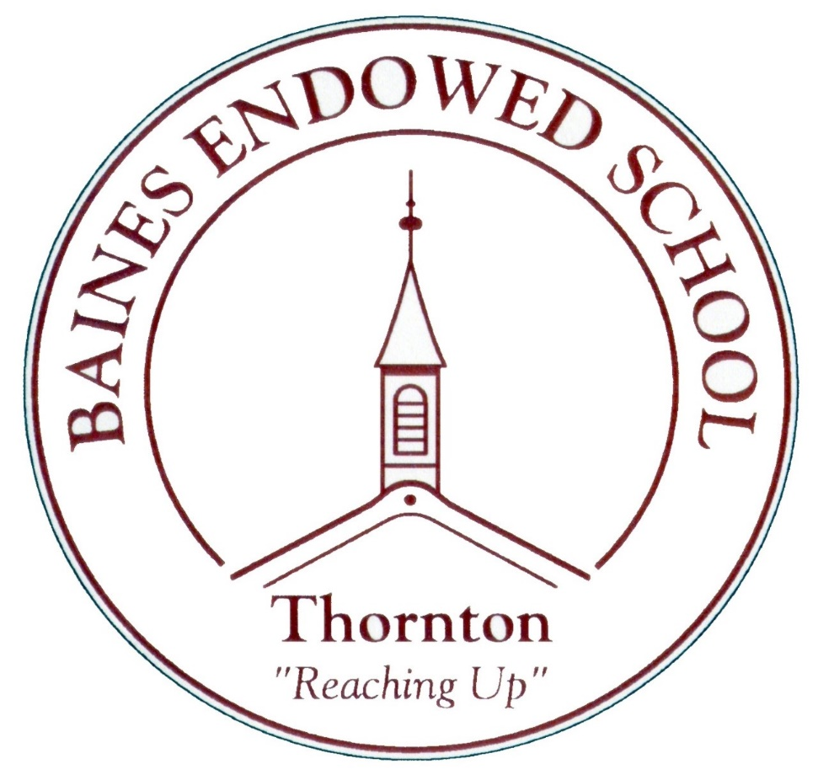

History Policy
September 2022

Baines Endowed VC School
Name of the History Subject Leads are: Miss Rachel Wilks and Miss Charlotte Haynes
At Baines Endowed VC school we follow the National Curriculum Programme of Study for History.
The following information is based on the National Curriculum Programmes of Study and the Early Years Foundation Stage (EYFS) Statutory Framework (March 2021)
A full version of the National Curriculum Programme of Study for History can be viewed at https://www.gov.uk/government/publications/national-curriculum-in-england-history-programmes-of-study

The Early Years Foundation Stage (EYFS) Statutory Framework (March 2021) can be viewed at:

https://www.gov.uk/government/publications/early-years-foundation-stage-framework--2

Purpose of studying History:

A high-quality history education will help pupils gain a coherent knowledge and understanding of Britain’s past and that of the wider world. It should inspire pupils’ curiosity to know more about the past. Teaching should equip pupils to ask perceptive questions, think critically, weigh evidence, sift arguments, and develop perspective and judgement. History helps pupils to understand the complexity of people’s lives, the process of change, the diversity of societies and relationships between different groups, as well as their own identity and the challenges of their time.
Aims:
Our history teaching aims to ensure that all pupils:
- know and understand the history of the British Isles as a coherent, chronological narrative, from the earliest times to the present day;
- know and understand significant aspects of the history of the wider world including the nature of ancient civilisations;
- gain and use a wide range of historical terms and vocabulary;
- understand historical concepts such as:
  - continuity and change,
  - cause and consequence,
  - similarity, difference and significance, and
- use them to make connections, draw contrasts, analyse trends and ask historically valid questions and create their own structured accounts, including written narratives
- understand the methods of historical enquiry, including how evidence is used to make historical claims
- gain historical perspective by making connections between local, regional, national and international history; between cultural, economic, military, political, religious and social history; and between short- and long-term timescales

Attainment targets / Assessment
The National Curriculum states that:
‘By the end of each key stage, pupils are expected to know, apply and understand the matters, skills and processes specified in the relevant (History) programme of study.’
Children’s attainment is assessed and recorded at the end of each year using the Lancashire end of Year Expectations (see separate document). This is used in conjunction with the Lancashire Key Learning document (progression in knowledge, skills and understanding.)
Subject content
EYFS (Past and Present Early Learning Goal)
Children at the expected level of development will:
- Talk about the lives of the people around them and their roles in society;
- Know some similarities and differences between things in the past and now, drawing on their experiences and what has been read in class;
- Recall some important narratives, characters and figures from the past encountered in books read in class.
Key Stage 1
- Pupils should develop an awareness of the past, using common words and phrases relating to the passing of time.
- They should know where the people and events they study fit within a chronological framework and identify similarities and differences between ways of life in different periods.
- They should use a wide vocabulary of everyday historical terms.
- They should ask and answer questions, choosing and using parts of stories and other sources to show that they know and understand key features of events.
- They should understand some of the ways in which we find out about the past and identify different ways in which it is represented.

Pupils should be taught about:
- changes within living memory – where appropriate, these should be used to reveal aspects of change in national life e.g. the Queen’s 90th Birthday, Remembrance Day
- events beyond living memory that are significant nationally or globally for example the Great Fire of London
- the lives of significant individuals in the past who have contributed to national and international achievements, some should be used to compare aspects of life in different periods . E.g:
  - Female scientists such as Marie Curie and Mary Anning (Y1)
  - Caxton and Tim Berners-Lee linked to the development of new technologies (Y2)
- significant historical events, people and places in their own locality

Key Stage 2
Pupils should continue to develop a chronologically secure knowledge and understanding of British, local and world history, establishing clear narratives within and across the periods they study. They should
- note connections, contrasts and trends over time and develop the appropriate use of historical terms;
- regularly address and sometimes devise historically valid questions about change, cause, similarity and difference, and significance;
- construct informed responses that involve thoughtful selection and organisation of relevant historical information;
- understand how our knowledge of the past is constructed from a range of sources.
In planning to ensure the progression described above through teaching the British, local and world history, teachers should combine overview and depth studies to help pupils understand both the long arc of development and the complexity of specific aspects of the content.
Pupils should be taught about: | In which year at our school?
1 Changes in Britain from the Stone Age to the Iron Age | Year 3
2 The Roman Empire and its impact on Britain | Year 3
3 Britain’s settlement by Anglo-Saxons and Scots | Year 4
4 The Viking and Anglo-Saxon struggle for the Kingdom of England to the time of Edward the Confessor | Year 4
5 A local history study | All Key Stage 2 Year Groups
6 A study of an aspect or theme in British history that extends pupils’ chronological knowledge beyond 1066 | Year 6 – Crime and Punishment from Anglo Saxons to Present Day
7 A study of the achievements of the earliest civilizations – an overview of where and when the first civilizations appeared and a depth study of one of the following: Ancient Sumer; The Indus Valley; Ancient Egypt; The Shang Dynasty of Ancient China. | Year 5  Overview plus Ancient Egypt.
8 Ancient Greece – a study of Greek life and achievements and their influence on the western world. | Year 6
9 A non-European society that provides contrasts with British history – one study chosen from: early Islamic civilization, including a study of Baghdad c. AD 900; Maya civilisation c. AD 900; Benin (West Africa) c. AD 900-1300. | Year 5  The Mayans/Baghdad
See NC Programme of Study for more details/ideas of what could be covered in each theme.
History Teaching
The school uses a variety of teaching and learning styles in History lessons. Our principal aim is to develop children’s knowledge. Skills and understanding in History and we use a variety of teaching and learning styles in our History lessons. We believe in whole class teaching methods and combine these with enquiry based research activities. We believe children learn best when:
They have access to and are able to handle history artefacts;
They visit museums and places of interest;
They have access to secondary sources such as books and photographs;
Visitors talk about personal experiences of the past;
They listen and interact with stories form the past;
They interview family and older friends about changes in their own and other people’s lives;
They use drama and dance to act out historical events;
They are shown or use independently, resources form the internet;
They are able to use non-fiction books for research;
They are provided with opportunities to work independently or collaboratively, to ask as well as answer, historical questions.

Planning
We carry out planning in three phases: long term, medium term and short term.
Long term Planning – Our long term planning is based on the requirements for History as taken from the National Curriculum for Key Stages 1 and 2. It gives coherent and manageable ‘teaching units’ for each year group and allows for curriculum continuity and progression in children’s learning.
Medium Term Planning: These plans, which form part of our creative curriculum, define the learning objectives and outcomes for each unit and suggest activities that will enable these to be achieved. The sequence of the activities outlined, promote progression and ensure an appropriate balance and distribution of work across each term.
Short term Planning: Individual plans are devised for each History lesson. These plans list the specific learning objectives for the lesion and give details on how to teach them. They build on the medium term plans.
Differentiation
We recognise the fact that we have children of differing abilities in all our year groups and so we provide suitable learning opportunities for all the children by matching the challenge of the task of the ability of the child. We achieve this through a range of strategies which are differentiated by task, expected outcomes and/or support from peers or adults.
Monitoring and Evaluation
History will be monitored by the History Leads who will be responsible for monitoring and evaluating the teaching of History in school. They will be responsible for gathering samples of curriculum work, and collecting evidence of displays, visits, assemblies and photographs of activities.
Class teachers are responsible for the ongoing evaluation of teaching methods and pupil progress.
This policy will be observed in practice by the subject leads on a regular basis following the Monitoring and Evaluation Schedule.

Displays
Displays will be used for a variety of purposes, which may:
Improve the environment;
Present information;
Encourage participation;
Demonstrate process;
Focus attention;
Reinforce learning and
Confirm values.

Links to Other Subjects
English
We expect the children to use the skills taught in English in their History lessons, such as:
- The spoken language where children are encouraged to discuss artefacts, evidence, sources, feelings and reactions to sources.
- Listening where children are expected to listen to others’ thoughts and feelings and to any visitors in or out of school, in order to gain historical understanding.
- Reading such as reading sources in order to help develop historical skills and concepts.
- Writing in order to be able to write facts or thoughts about historical concepts, artefacts and sources.
- Vocabulary Development where children are introduced to a variety of different vocabulary related to their historical topics as they move through the school.
Computing
- Children will be ae to develop their IT in a variety of ways, such as:
- Using the internet to investigate the work of famous people and events;
- Use digital cameras and video equipment to record observations and pieces of their own work;
- Use email.

Inclusion
Success is expected for all children. They are expected to work to their full potential, recognise personal strengths and celebrate their own achievements and those of others, both within the school and the wider community.
At Baines Endowed, teaching will ensure that History is accessible to all children by planning History lessons that:
Are challenging for children of different abilities and aptitudes in each year group of each Key Stage;
Motivate children, enabling them to understand and review their own learning;
Cater for children’s diverse learning needs;
Overcome potential barriers to learning and assessment for individuals and groups of children;
Differentiate work through activities and expected outcomes;
Use other adults to support all ability groups.
Equal Opportunities
All children should have access to the whole History curriculum and resources, regardless of race or gender. There are opportunities for researching and drawing information from other cultures. An appreciation of historic achievements by diffident cultures should be taught.
Subject Knowledge
All staff teaching any aspect of History, must ensure that they have a secure subject knowledge, are able to foster and maintain children’s interest in the subject and address and misunderstandings. They must also demonstrate a critical understanding of developments in the subject area.
The Role of the History Subject Lead
The role of the subject lead is to:
- Seek to enthuse pupils and staff about History and promote high achievement;
- Advise and support staff in the panning, delivery and assessment of History;
- Offer specialist advice and knowledge for children with SEND and more able pupils;
- Monitor and evaluate the standards of children’s work and the quality of teaching in History throughout the school;
- Undertake lesson observations of History teaching across the school;
- Keep up to date with current developments by attending courses and disseminate this information to staff through INSET and staff meetings;
- Highlight any training needs for staff or particular staff;
- Purchase, organise and maintain teaching resources and manage a delegated budget;
- Write a School Improvement Plan for History (SIP);
- Advise the Headteacher of any action required and keep them informed of strengths and areas for development in the subject.

Other Information
Lancashire Archives - email: archives@lancashire.gov.uk
Mario - Lancashire County Council's online map-based resource tool. http://mario.lancashire.gov.uk/agsmario/
Lancashire County Council's Archaeology Service. https://www3.lancashire.gov.uk/environment/oldmap/

Historical Association for key information, schemes of work and other resources. https://www.history.org.uk/
Historical maps and links with geography http://digimapforschools.edina.ac.uk
Google Street View. https://www.google.com/streetview/

Contact skenyon.lancsenglish@outlook.com for further information.

