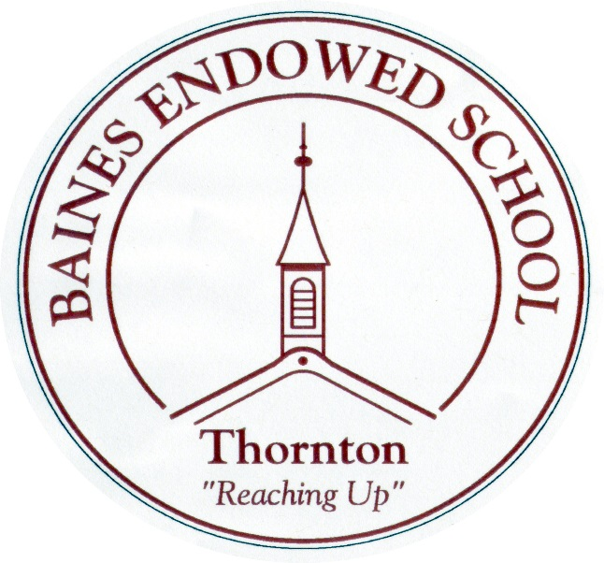

Art and Design Policy

September 2022

Baines Endowed Art and Design Policy
September 2022

This policy reflects the school values and philosophy in relation to the teaching and learning of Art and Design. It sets out the framework within which teaching and non-teaching staff can operate and gives guidance on planning, teaching and assessment.

The school aims to:
- Develop knowledge, understanding and enjoyment of Art and Design

- Develop the pupils’ ability to observe, learn about and record from the world around them

- Use a variety of materials, tools and processes, including ICT, safely, experimentally and with increasing confidence, technical control and skill

- Develop pupils’ ability to express their own responses, feelings and ideas using visual, tactile, verbal and written means where appropriate

- Recognise the contribution that Art makes to learning in other subjects and aspects such as literacy, numeracy and the spiritual and moral dimensions

- Develop an increasing knowledge and understanding of the contribution of artists, designers, architects and craftspeople to this and other cultures, past and present.

- Develop the ability to discuss and evaluate their own work and that of others in a constructive, but critical manner, developing a specialist vocabulary

- Develop the ability to recognise different kinds of art, craft and design and why and how they are different

- Develop aesthetic sensitivities so that they can respond sensitively and thoughtfully

- Develop the pupils’ ability to nurture their own unique and personal ideas, working with increasing confidence

The policy should be read in conjunction with the National Curriculum for Art and Design 2014.

Aims
Art is a foundation subject within the National Curriculum.
The subject comprises of Programme of Study and Skills. By the end of each Key Stage, pupils are expected to know, apply and understand the matters, skills and processes specified in the relevant programme of study.
Art in the Foundation Stage is part of the Expressive Arts and Design section of the EYFS.
Our pupils will work at levels appropriate to their age and ability to ensure progression and increasing challenge. Teachers will follow the intended progression for their phase, drawing on previous and later phases depending on the level of the child. Children will be given chances to develop their own artistic style through independent exploration.
Art will develop visual awareness in pupils.
Pupils will be given the opportunity to use Art to record their feelings and express their creative imagination across the curriculum.
Pupils will develop their visual vocabulary and understanding of the visual elements, in order that they can effectively express themselves through artistic means.
Art will develop pupils’ critical abilities and understanding of their own and others cultural heritage.
Pupils will be given the opportunity to acquire skills and develop artistic techniques.

Organisation
Art and Design is organised to develop specific subject skills and techniques as well as integrating with other subjects, developing cross-curricular themes and skills.
Learning activities provide pupils with practical experience with a range of media, both 2D and 3D. This includes educational visits, the use of published resources for teacher planning, outdoor learning experiences and ICT when appropriate.
Progression will be indicated through the use of sketchbooks which will follow the pupils through the school from the Autumn Term of Year 1 up to Year 6, in keeping with the Key Stage’s Programme of Study for the National Curriculum 2014.

Time Allocation
Art is planned through an integrated approach so the amount of time devoted weekly will vary. Maintaining breadth and balance, the time allocated to Art is at the class teacher’s discretion. However, teachers should dedicate the equivalent of one hour per week, for at least three half terms of the year, to Art and Design.
Teachers should aim to allocate different times of the week to Art in order to draw on pupils’ skills and environment at different times of the day.

Class Organisation and Teaching Style
The teaching styles utilised for Art will be those deemed appropriate for the task, in which whole class and direct instruction methods will be combined with group/individual methods. Pupils will be encouraged to explore materials, involving first-hand experience wherever possible, but teachers will offer guidance and instruction on skills and processes where appropriate. The knowledge content of the curriculum, including critical studies and the visual elements, may involve some formal teaching in class, group and individual ways.
Teachers should plan from skills-based objectives for all Art sessions, including the skill they will be using and the desired outcome.

Display/Presentation
Teachers will ensure that their classroom is a visually stimulating environment to motivate pupils in their art work, as well as including a range of exciting objects for first-hand stimulus. Displays around school will sometimes, showcase children’s artwork, including progression and end product.
Pupils should be encouraged to take their time and work to the best of their ability for display. They should also be given the opportunity to display their own work how they wish it to be seen.

Blended Learning
By developing a blend of in-school and distance learning, teachers can support students and help to individualise learning, increase learners’ autonomy, motivation and agency and improve learning skills towards becoming self-directed learners.
To do this in Art, teachers will set and respond to tasks using online platforms such as Purple Mash, You Tube, and Class Dojo etc. These will be used as homework or work to be completed in school.
Teachers will share videos with parents/carers and children to introduce new units of work. These will highlight learning from previous year groups (where applicable) and the skills that children will have used before and are to build upon. Key vocabulary to be used in the forthcoming unit and skills to be developed will also be introduced.

Assessment and Record Keeping
Assessment is used to inform future planning and provide information about individuals throughout their time in school.
Assessment techniques used will ensure that teachers assess the on-going process and not just the finished products or outcomes.
These techniques will include:
- Teachers’ observation of pupils
- Teacher- pupil discussion and teacher questioning
- Pupils’ sketchbooks; rough drawings
- Examples of pupils’ work- photographs of display
- Pupils’ ongoing analysis of their achievements
- Photographs of children engaged in art and craft activities
- Assessment in the Foundation Stage is part of the EYFS profile
- More able pupils identified by teachers and creative opportunities planned accordingly
NB: The pupils’ sketchbooks are their own personal explorations and developments, so should not be formally marked by teachers, but discussed with pupils.

Subject Leader Role
The teacher responsible for Art and Design is Sian Andrew. The link teaching assistant for Art is Rebecca Thornton. The subject leader is responsible for updating the Art and Design Policy and School Improvement Plan for Art and Design. She also liaises with other staff and outside agencies to give pupils the opportunity to use their artistic and creative skills, keeping a list of more able pupils. The Art leader is also responsible for ordering Art materials- any requests should be made to her directly before the budget is finalised- and organise Arts Week annually.

Organisation of Resources/Materials
A basic range of materials will be available in each classroom to ensure continuity of experience as the child progresses through the school. Staff are given the opportunity to supplement these materials according to need, from a central store.
Resources are managed by the Art leader and held centrally to be used by individual staff as appropriate. The Art store should be kept tidy and all resources returned to the correct location after use. Staff are to report to the Art leader if they have requests for specific resources and materials, however this needs to be actioned during the previous half term to allow resources to be obtained. Resources and materials will be updated according to New Curriculum updates and topics.

Equal Opportunities
The whole school policy on equal opportunities will be adhered to in Art activities. In particular the Art programme will ensure that pupils are exposed to a balance of artists from both genders and from a range of cultures.

Differentiation and SEND.
In Art activities differentiation is mainly by outcome, though in cases where pupils have special educational needs there may be the need to differentiate the task. Particular care will be taken to ensure that critical studies do not disadvantage the less able. In the case of More Able individuals, pupils will be encouraged to explore their creativity and take part in extra-curricular activities involving the Arts. They may also be taught further discreet skills individually or in small groups.

British Values
Art lessons should provide an opportunity for pupils to engage in making art and at the same time reinforcing the fundamental British values of democracy, the rule of law, individual liberty, and mutual respect and tolerance of those with different faiths and beliefs in an exciting and visual way. Teaching staff can develop further work around British values using these art sessions as a springboard. Displaying the work is a powerful way to reinforce the values.
Online learning
Due to the increase in use of internet connected devices and more work being completed online, online safety is an essential part of all curriculum areas.
In Art the children may be expected to complete work online in school or at home.
Online safety is taught as a discrete part of the computing curriculum and reinforced through regular, safeguarding assemblies. Nevertheless, when the internet is used for Art, children are reminded of the golden rules of online safety:
Don’t share personal information
Be polite, kind and respectful
Tell a trusted adult if you come across something that makes you feel uncomfortable or unhappy

S. Andrew
September 2022

