Early Help Offer

Our school is committed to working with families to ensure the best possible outcomes for children. This includes supporting children and their families to thrive. At Baines Endowed VC School, we use the Lancashire ‘Level of Need’ as a basis to our ‘Early Help’:
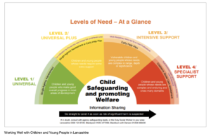
As part of this work, we use the Lancashire Early Help Assessment framework.
More About the Early Help Assessment….
The Early Help Assessment helps school to work in partnership with a family from a holistic and strength-based approach to gather, explore and analyse with families information about all aspects of the child (and their family’s) life. In doing so, the aim is to identify areas where change will help to meet any identified support needs and positively impact on their lived experiences. As part of this work, we signpost to support from other agencies, including:
Children and Families Wellbeing Service
Click on the images to find our more about the service…
To find out more about what’s available to you, please click on the QR code below to locate your nearest Children and Family Wellbeing Service (previously children’s centres and Young People’s Service)…

Our local Children and Family Wellbeing Service is based at:
Thornton Primary School,
Heys Street,
Thornton-Cleveleys.
FY5 4JP
Email:
kate.brown@lancashire.gov.uk
Telephone:
01253 741117

Working Well with Children and Families in Lancashire
Please click on the images below to find out more about the Early Help offer within Lancashire…
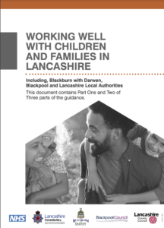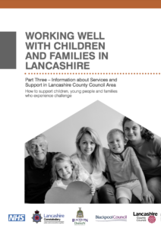
Referrals to Children’s Social Care
Anyone can raise a concern about the safety and welfare of a child by calling 0300 123 6720 (or between 8.00pm – 8.00am on 0300 123 6722.)

