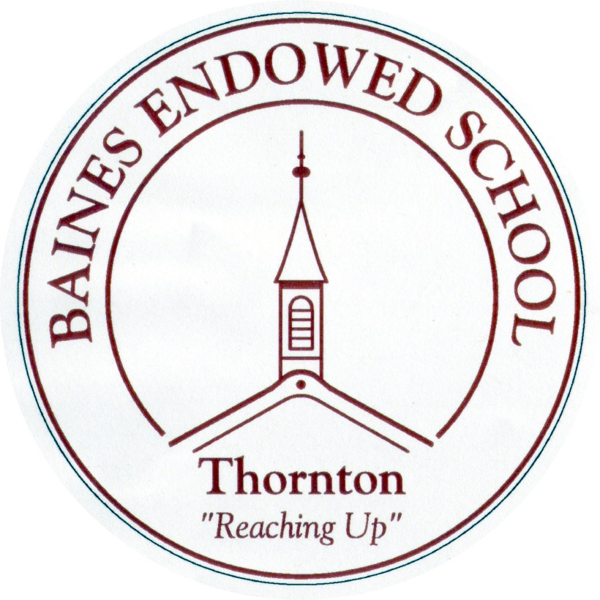

Phonics and Early Reading Policy
January 2022

Introduction
At Baines Endowed Primary school we are determined that every pupil will learn to read and write, regardless of their background, needs or abilities. We aim for all pupils to make sufficient progress to meet or exceed age-related expectations. We believe that our Phonics Programme and rigorous approach to reading and writing will enable all our pupils to become successful, fluent readers and writers by the end of Key Stage 1 and go onto developing their love of reading into Key Stage 2 and beyond. It is essential that our approach to teaching phonics and reading is accessible to all learners, regardless of background.

Intent
Phonics (reading and spelling)
At Baines Endowed, we believe that all our children can become fluent readers and writers. This is why we teach reading through Little Wandle Letters and Sounds Revised, which is a systematic and synthetic phonics programme. We start teaching phonics in Reception and follow the Little Wandle Letters and Sounds Revised progression, which ensures children build on their growing knowledge of the alphabetic code, mastering phonics to read and spell as they move through school.
As a result, all our children are able to tackle any unfamiliar words as they read. At Baines Endowed, we also model the application of the alphabetic code through phonics in shared reading and writing, both inside and outside of the phonics lesson and across the curriculum. We have a strong focus on language development for our children because we know that speaking and listening are crucial skills for reading and writing in all subjects.

Comprehension
At Baines Endowed, we value reading as a crucial life skill. By the time children leave us, they read confidently for meaning and regularly enjoy reading for pleasure. Our readers are equipped with the tools to tackle unfamiliar vocabulary. We encourage our children to see themselves as readers for both pleasure and purpose.
As we believe teaching every child to read is so important, we have a Reading Leader who drives the early reading programme in our school. This person is highly skilled at teaching phonics and reading, and they monitor and support our reading team, so everyone teaches with fidelity to the Little Wandle Letters and Sounds Revised programme.

Implementation
Daily phonics lessons in Reception and Year 1
- We teach phonics for 30 minutes a day. In Reception, we build from 10-minute lessons, with additional daily oral blending games, to the full-length lesson as quickly as possible. Each Friday, we review the week’s teaching to help children become fluent readers.
- We follow the Little Wandle Letters and Sounds Revised expectations of progress:
  - Children in Reception are taught to read and spell words using Phase 2 and 3 GPCs, and words with adjacent consonants (Phase 4) with fluency and accuracy.
  - Children in Year 1 review Phase 3 and 4 and are taught to read and spell words using Phase 5 GPCs with fluency and accuracy.

Daily Keep-up lessons ensure every child learns to read
- Any child who needs additional practice has daily Keep-up support, taught by a fully trained adult. Keep-up lessons match the structure of class teaching, and use the same procedures, resources and mantras, but in smaller steps with more repetition, so that every child secures their learning.
- We timetable daily phonics lessons for any child in Year 2 or 3 who is not fully fluent at reading or has not passed the Phonics screening check. These children urgently need to catch up, so the gap between themselves and their peers does not widen. We use the Little Wandle Letters and Sounds Revised assessments to identify the gaps in their phonic knowledge and teach to these using the Keep-up resources – at pace.

Teaching reading: Reading practice sessions three times a week
- We teach children to read through reading practice sessions three times a week. These:
  - are taught by a fully trained adult to small groups of approximately six children
  - use books matched to the children’s secure phonic knowledge
  - are monitored by the class teacher, who rotates and works with each group on a regular basis.
- Each reading practice session has a clear focus, so that the demands of the session do not overload the children’s working memory. The reading practice sessions have been designed to focus on three key reading skills:
  - decoding
  - prosody: teaching children to read with understanding and expression
  - comprehension: teaching children to understand the text.
- In Year 2 and 3, we continue to teach reading in this way for any children who still need to practise reading with decodable books but if they are ready to move on, we use the carousel approach that is used in Key Stage 2.

Additional reading support for vulnerable children
- Children in Reception and Year 1 who are receiving additional phonics Keep-up sessions read their reading practice book to an adult daily.

Ensuring consistency and pace of progress
- Every teacher in our school has been trained to teach reading, so we have the same expectations of progress. We all use the same language, routines and resources to teach children to read so that we lower children’s cognitive load.
- Weekly content grids map each element of new learning to each day, week and term for the duration of the programme.
- Lesson templates, Prompt cards and How to videos ensure teachers all have a consistent approach and structure for each lesson.

Ensuring reading for pleasure
We value reading for pleasure highly and work hard as a school to grow our Reading for Pleasure pedagogy.
- We read to children every day. We choose these books carefully as we want children to experience a wide range of books, including books that reflect the children at Baines Endowed and our local community as well as books that open windows into other worlds and cultures.
- Every classroom has an inviting book corner that encourages a love for reading. We curate these books and talk about them to entice children to read a wide range of books.
- The school library is made available for classes to use at various times during the week.

Impact
Assessment
Assessment is used to monitor progress and to identify any child needing additional support as soon as they need it.
- Assessment for learning is used:
  - daily within class to identify children needing Keep-up support
  - weekly in the Review lesson to assess gaps, address these immediately and secure fluency of GPCs, words and spellings.
- Summative assessment is used:
  - every six weeks to assess progress, to identify gaps in learning that need to be addressed, to identify any children needing additional support and to plan the Keep-up support that they need.
- The Little Wandle Letters and Sounds Revised placement assessment is used:
  - with any child new to the school to quickly identify any gaps in their phonic knowledge and plan provide appropriate extra teaching.

Statutory assessment
- Children in Year 1 sit the Phonics screening check. Any child not passing the check re-sits it in Year 2.

This policy was written April 2020 by Lizzie Hedges – the policy will be reviewed each year.
This policy has been reviewed and adapted in January 2021 by Lizzie Hedges to comply with the new SSP Little Wandle Letters and Sounds. – L.Hedges

