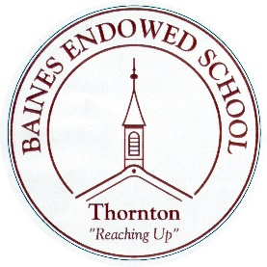
Baines Endowed Voluntary Controlled School - Key Stage 2 Performance Data – 2018 – 2019
Number of pupils eligible for assessment – 29
Number of boys – 11
Number of girls – 18
Number of Pupil Premium children – 4
Number of children with SEND – 5
Reading | %Expected+ | %Higher Level | Average Scaled Score | Average Progress Score
School | 72% | 31% | 104.4 | -1.61
Local | 71.7% | 24.3% | 103.8
National | 73% | 26.9% | 104.4

Writing | %Expected+ | %Higher Level | Average Progress Score
School | 83% | 18% | -1.90
Local | 77.6% | 20.2%
National | 78% | 20%

Maths | %Expected+ | %Higher Level | Average Scaled Score | Average Progress Score
School | 83% | 24% | 105.1 | -1.32
Local | 78.1% | 24% | 104.6
National | 79% | 27% | 105.0

Grammar, Punctuation and Spelling | %Expected+ | %Higher Level | Average Scaled Score
School | 79% | 45% | 107
Local | 77.4% | 32.2% | 105.8
National | 78% | 36% | 106

Reading, Writing and Maths Combined | %Expected+ | %Higher Level
School | 64.3% | 7.1%
Local | 63.5% | 9.7%
National | 65% | 10.5%

