PURPLE MASH COMPUTING SCHEME OF WORK - KNOWLEDGE ORGANISER
Unit: 6.5 – Text Adventures
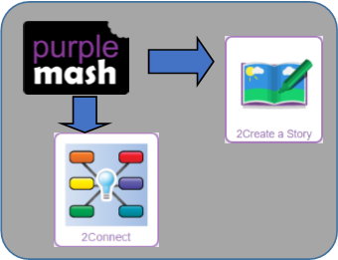
Text-based adventure - A computer game that uses text instead of graphics.
Concept map - A tool for organising and representing knowledge. They form a web of ideas which are all interconnected.
Debug - Identify and remove errors from (computer hardware or software).
Sprite - A computer graphic which may be moved on-screen.
Function – In this context, a section of code that gets run when it is called from the main code. A function in a program is usually a piece of code that gets run lots of times.
Key Resources
Key Vocabulary
Key Learning
To find out what a text adventure is.
To plan a story adventure.
To make a story-based adventure.
To introduce map-based text adventures.
To code a map-based text adventure.

Key Images

Key Questions

What is a text based adventure?
A text based adventure is a type of game that uses text rather than graphics to tell the story. The player normally selects the next move from a series of text based options.
Create an adventure story in 2Create a Story | 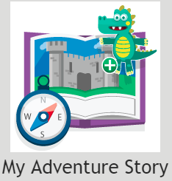
Plan out your story | 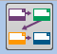
Add a button to the story
Add a sprite to the story
Add sound to the story
Choose a background
Undo or redo the last action
Play your text based adventure

Why is it important to plan a text based adventure?

Text based adventures can often be complicated and give the player lots of options about what to do next. Planning the game ensures the player doesn’t make a decision that has no outcome.

