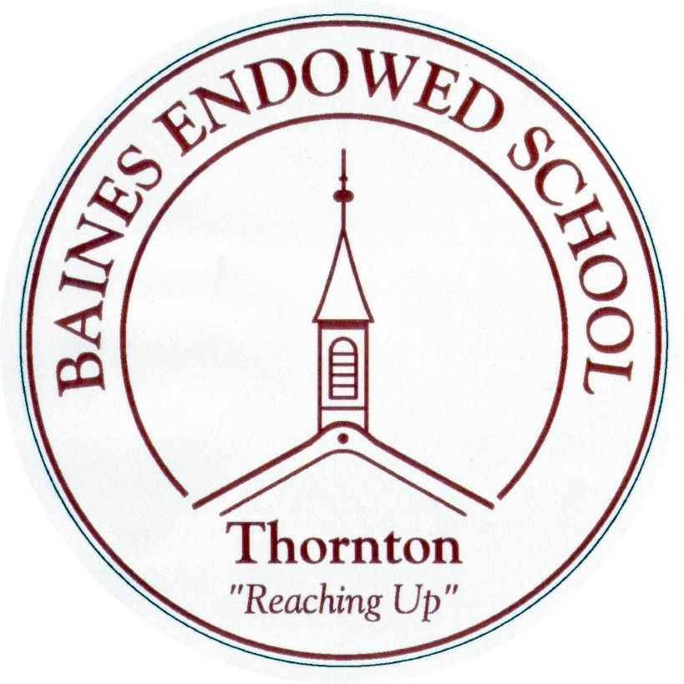
Drug, Alcohol and Tobacco Education Policy
September 2020

Baines Endowed VC Primary School

DRUG ALCOHOL AND TOBACCO EDUCATION POLICY

INTRODUCTION
Our school believes that the misuse of drugs, alcohol and tobacco (DAT) endangers not only our pupils but also affects the wider community in which we live. It is the school’s responsibility to ensure the child’s health and safety while in our care and we also strive to promote their personal and social wellbeing. DAT misuse undermines this and hinders the development of the young person. This policy aims to highlight the school’s positive and proactive approach to Drug, Alcohol and Tobacco Education. It also aims to ensure that all pupils have access to consistent, clear and thoroughly planned approaches to Drug, Alcohol and Tobacco education that is appropriate to the age and maturity of the pupils.
The school aims to:
- Enable pupils to make informed healthy and safe choices by increasing their knowledge, challenging their understanding and developing their skills.
- Support children in developing their communication skills to help them to assert themselves, resist pressure and make responsible decisions.
- Provide accurate and comprehensive information about substances.

RATIONALE
Baines Endowed VC Primary School recognises that young people in today’s society are exposed to the risks associated with the drug culture that exists in the modern world.
The school wishes to promote the development of the ‘whole person’ which encompasses physical, mental, emotional, social and environmental health; by equipping pupils with the knowledge, skills, attitudes and values to handle their lives effectively in the present and prepare them for adulthood.
Drugs education should therefore form an integral part of the school curriculum.
DEFINITION OF DRUGS
For the purpose of this policy, the term ‘drugs’ refers to substances that change the way the body or mind work, including;
- Alcohol
- Tobacco, including Shisha
- Volatile substances
- Caffeine
- Over the counter prescribed drugs e.g painkillers, antibiotics
- Illegal drugs e.g. ecstasy, cannabis, cocaine, crack and heroin
‘Drugs misuse’ is defined at the non-medical use of drugs that are only intended for use in medical treatment, the use of drugs that have no accepted medical purpose (DfE circular 4/95).

DEFINITION OF DRUGS
A drug is any substance which, when taken, has the effect of altering the way a person behaves, feels, sees or thinks. As well as everyday substances such as tea and coffee, drugs include:
- Alcohol and tobacco
- ‘Over the counter’ medicines such as paracetamol for headaches
- Prescribed drugs, such as antibiotics and tranquilisers
- Volatile substances such as glues and aerosols
- Illegal drugs such as cannabis, LSD and ecstasy
The school recognises that this policy focuses mainly on illicit drugs

THE PLACE OF DRUGS EDUCATION WITHIN THE CURRICULUM
Drug education should not be seen as a one off topic but as a continuous process which involves the development of skills and attitudes enabling pupils to make informed choices. Effective drug education should take account of not only the individual, but also the family, their peer groups and the wider community. Where possible, the school promotes the partnership between the parent and child, when addressing drug issues.
At Key Stages 1 and 2, the statutory curriculum for pupils includes the cross curricular theme of Health Education. This theme provides opportunities for young people to develop their knowledge and understanding of the use, misuse, risks and effects of drugs and other potentially harmful substances, their effects of health and lifestyle, in line with the five Every Child Matters outcomes.
The National Curriculum in Science requires that:
- Pupils in KS1 should be taught about the role of drugs and medicines (Sc2, 2d).
- Pupils in KS2 should be taught about the effects on the human body of tobacco, alcohol and other drugs, and how these relate to their personal health (Sc2, 2g).

THE DELIVERY AND ORGANISATION OF THE DRUGS EDUCATION PROGRAMME
Drugs Education is a whole staff issue. Baines Endowed VC Primary School ensures that staff are regularly updated with changes in the curriculum and changes to the policy, which have an effect on their delivery of the curriculum. Where possible, staff will receive in-service training on drug issues.

OUTSIDE AGENCIES
Baines Endowed VC Primary School may use outside agencies: school nurses, the police or other external agencies to support the delivery of lessons. The teacher must ensure that the following criteria are met:
- The content and delivery of the programme has been jointly agreed.
- The programme and methods of delivery are consistent with the aims and objectives outlined in this policy.
- The Head Teacher has given approval for the use of the outside agency.

CONFIDENTIALITY
The welfare of children will always be central to the school’s policy and practice. All pupils need to feel able to talk in confidence to a member of staff about a drug-related problem. However, in line with Child Protection procedures, teachers will not be able to promise complete confidentiality and information about a child in relation to drugs with follow the same procedure as for other sensitive information.
Pupils should also be encouraged to talk to their parents. A record will be made of the disclosure and the Head Teacher is to be informed.

MONITORING AND EVALUATING
This policy is a working document and will be reviewed every year.
The induction of new staff will include introduction to this policy.
The policy is available to parents if they request it.

Mrs K. Maddison – July 2016
Reviewed October 2017 – Mrs L. Hedges
Reviewed September 2018 – L.Hedges
Reviewed September 2019 – L. Hedges
Reviewed April 2020 – L. Hedges

